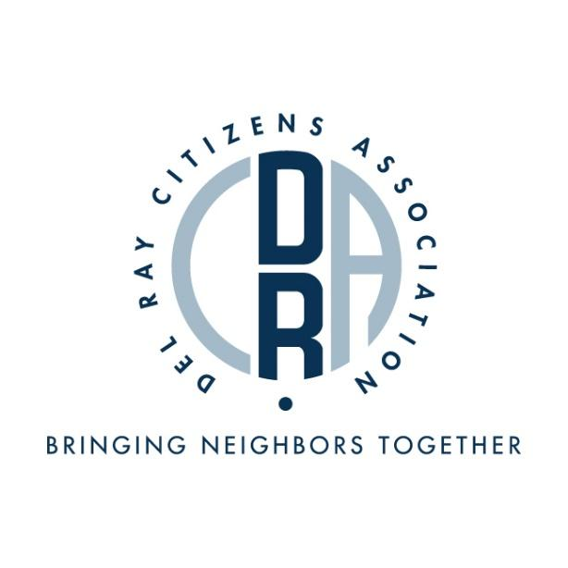

**7TH ANNUAL DRCA CHILI COOK-OFF RULES & APPLICATION**

The 7th Annual Chili Cook-off will be held on Saturday, February 22, from 6:00 p.m. until 7:30 p.m.

Deadline for submitting an early bird ($15) application: February 5.

Deadline for all applications: February 19.

**RULES:**

You must be a Del Ray resident to compete in this event.

Single entries or teams (maximum 3 people) are welcome. Typical table size is 6 feet wide x 3 feet deep. Table location will be on a first-come basis. Contestants must furnish their own ingredients, equipment (except tables), utensils, and fuel. Power and tables will be supplied but extension cords and power strips and are the responsibility of contestants; contestants are encouraged to bring portable cooktops (for indoor use). All contestants are responsible for the maintenance of chili’s proper temperature for serving.

Each contestant must cook a minimum of **six quarts** of chili, prepared in one batch prior to the event.

DRCA will provide spoons and cups for serving to the attendees and judges.

**THE COMPETITION:**

There are three prize categories totaling $450 in prizes:

* 1st place MEAT (determined by judges): $150 check
* 1st place VEGETARIAN (determined by judges): $150 check
* 1st place PEOPLE’S CHOICE (each attendee is allowed one vote): $150 check

There will be three judges, who are typically Alexandria community leaders. They will be looking for taste, aroma, texture, and after-taste. Your chili can certainly be spicy, but it isn’t a requirement.

While professional chefs are ineligible to win the judged competition, a professional chef is eligible to win the People’s Choice award. The winner of either the Meat or Vegetarian competition may also win the People’s Choice award.

**ENTRY:**

The entry fee is $20 per chili. Contestants may enter more than one batch of chili. A separate application and entry fee is required for each batch. Each chili may only compete in one of the two judged categories (MEAT or VEGETARIAN). As noted above, professional chefs are permitted to participate in the cook-off but are only eligible to win the People’s Choice award.

**INGREDIENTS:**

Use your favorite recipe, with or without meat, and with or without beans. Meat may be beef, pork, lamb, chicken, or turkey (game meats are also allowed, but only if commercially purchased). Vegetarian entries must, obviously, be meatless.

Please have a list on hand of all the ingredients used in your chili for allergy-confirmation purposes. If peanuts are or peanut oil is used, please display a warning sign. You may not use canned, store-bought chili or mixes, but pre-cooked beans are okay. All chili must be cooked to completion prior to the event; chili is to be brought ready to eat. You may serve your chili with condiments.

**LOGISTICS:**

Set-up is from 5:00 p.m. until 6:00 p.m. You may decorate your table however you like, and feel free to promote your business at your table!

The event itself is from 6:00 p.m. until 7:30 p.m. Please be prepared for attendees to taste and vote for the entire 1.5 hours. Each contestant or team will be given a contestant’s number. Your number will be visible to the judges and the public. The public voters each get one vote that they will drop in a ballot box.

The award ceremony will be at 7:30 p.m.

**LOCATION:**

Commonwealth Academy Gym

1321 Leslie Avenue

Alexandria, VA 22301

*(application on next page)*

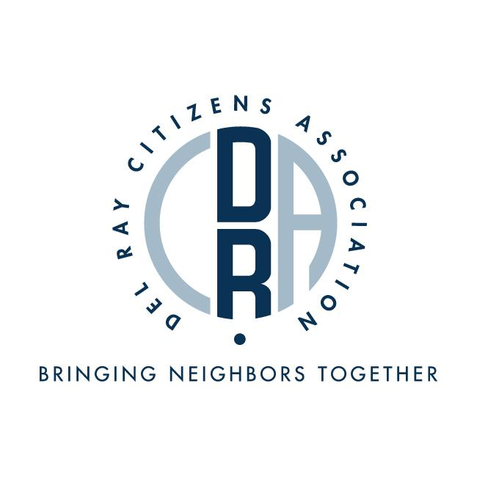

**DEL RAY CITIZENS ASSOCIATION 7TH ANNUAL CHILI COOK-OFF REGISTRATION FORM**

**Saturday, February 22, 2019**

**For entry**: Fill out this entry form and email to [drca_activities_director@delraycitizen.net](mailto:drca_activities_director@delraycitizen.net), then pay the $20 entry fee **($15.00 for entries received prior to February 5)** through the Eventbrite page (<https://www.eventbrite.com/e/7th-annual-del-ray-citizens-association-chili-cook-off-tickets-88601159453>). If you’d like to pay a different way, please contact [execboard@delraycitizen.net](mailto:execboard@delraycitizen.net).

**ALL ENTRIES DUE BY** **February 19, 2019**.

Name: ___________________________________________________________

Team Name: ______________________________________________________

Chili Name: _______________________________________________________

Phone Number: ___________________________________________________

Address (must be Del Ray resident): ____________________________________

City: _____________________________________________________________

State: ____________________________________________________________

Zip: ______________________________________________________________

Email Address: _____________________________________________________

Certification: I certify that I have received a copy of the official rules and that I agree to abide by them. I understand that a violation may disqualify my team from the competition and any awards or prizes.

Signature: _________________________________________________________

Print Name: _______________________________________________________